**POINTERS**

SARTHAK SANAY

**(1) AIM:-**

To write programs in C to demonstrate the usage of pointers (pointer arithmetic, passing pointers to functions).

**CODE 1:- (Pointer Arithmetic)**

**// Program in C to demonstrate Pointer Arithmetic**

**#include <stdio.h>**

**int main()**

**{**

**// Pointer Increment and Decrement**

**printf("Pointer Increment (char data type):-\n");**

**char c= 'A';**

**char *cp= &c;**

**printf("cp = %d\n", cp);**

**cp++;**

**printf("cp++ = %d\n", cp);**

**// Addition of Integer to Pointer**

**printf("\nAddition of Integer to Pointer:-\n");**

**int a= 22;**

**int *p = &a;**

**printf("Pointer before Addition: %u\n", p);**

**p= p+250;**

**printf("Pointer after Addition: %u\n", p);**

**// Addition of two pointers**

**printf("\nAddition of two pointers:-\n");**

**int n1= 100, n2= 200, sumOfPtr;**

**int *ptr1= &n1, *ptr2= &n2;**

**sumOfPtr= *ptr1 + *ptr2;**

**printf("ptr1 = %d\n", ptr1);**

**printf("ptr2 = %d\n", ptr2);**

**printf("ptr1 + ptr2 = %d\n", sumOfPtr); // 4 is converted into 1, i.e why output given is 300**

**// Comparision of two pointers**

**printf("\nComparision of two pointers:-\n");**

**if(ptr1 == ptr2)**

**printf("Pointer 1 and Pointer 2 are equal.");**

**else**

**printf("Pointer 1 and Pointer 2 are not equal.");**

**return 0;**

**}**

**OUTPUT SCREEN 1:-**

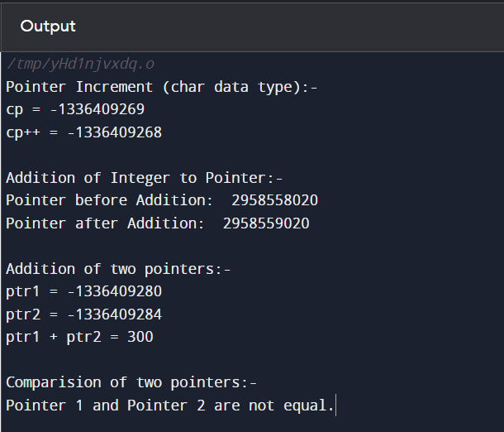

**CODE 2:- (Passing Pointers to Functions)**

**// Program in C to demonstrate the passing of pointers to functions**

**#include <stdio.h>**

**int swap(int *a, int *b)**

**{**

**\*a = 100;**

**\*b = 200;**

**}**

**int main()**

**{**

**int a=10, b=20;**

**printf("Before Changes:-\na = %d\t\tb = %d\n",a, b);**

**swap(&a, &b);**

**printf("After Changes (by passing pointers):-\na = %d\t\tb = %d",a, b);**

**return 0;**

**}**

**OUTPUT SCREEN 2:-**

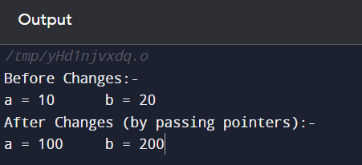

**(2) AIM:-**

To write programs in C by implementing functions to swap values using pointers and without using pointers.

**CODE 1:- (Using pointers)**

**// Program in C to create a function to swap two values by passing pointers**

**#include <stdio.h>**

**void swap(int *a, int *b)**

**{**

**int temp;**

**temp = *a;**

**\*a = *b;**

**\*b = temp;**

**}**

**int main()**

**{**

**int a=10, b=20;**

**printf("Original Values:-\na = %d\t\tb = %d\n",a, b);**

**swap(&a, &b);**

**printf("After Swapping:-\na = %d\t\tb = %d",a, b);**

**return 0;**

**}**

**OUTPUT SCREEN 1:-**

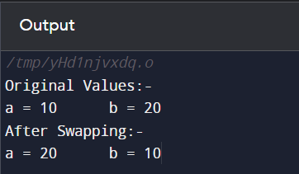

**CODE 2:- (Without using pointers)**

**// Program in C to demonstrate swapping of two variables without passing pointers**

**#include<stdio.h>**

**void swap(int a, int b)**

**{**

**int temp;**

**temp= a;**

**a= b;**

**b= temp;**

**printf("After Swapping:-\na = %d\t\tb = %d",a, b);**

**}**

**int main()**

**{**

**int a=10, b=20;**

**printf("Original Values:-\na = %d\t\tb = %d\n",a, b);**

**swap(a,b);**

**return 0;**

**}**

**OUTPUT SCREEN 2:-**



**(3) AIM:-**

To write a program in C to find the sum of elements in an array using pointers.

**CODE :-**

**#include <stdio.h>**

**int main()**

**{**

**int n, sum=0;**

**printf("Enter size of array: ");**

**scanf("%d", &n);**

**int arr[n];**

**printf("Enter Array elements:- \n");**

**for(int i=0; i<n; i++)**

**{**

**printf("Enter element %d: ", i);**

**scanf("%d", &arr[i]);**

**}**

**int *ptr= arr; // Setting address of first array element to *ptr**

**for(int i=0; i<n; i++)**

**{**

**sum= sum + *ptr;**

**ptr++; // Incrementing pointer by one to get next element**

**}**

**printf("The sum of elements of Array is: %d", sum);**

**return 0;**

**}**

**OUTPUT SCREEN :-**

